Willow Brook Elementary School

Title I School-Family Compact

The faculty of Willow Brook Elementary School believes that education is a cooperative effort between family, school, and community that support our children’s well-being. Parents are a child’s first and best teachers! We count on you, and you can count on us to love your child and challenge him/her to achieve their greatest potential. Parent involvement is so critical that staff and teachers can have little impact without the help and support from a child’s parents.

This document outlines how parents, students, and staff of Willow Brook Elementary School can work together to create a safe and welcoming environment that supports student achievement. This School-Family Compact is in effect during the 2020-2021 school year.

Please read this compact, sign, and return it to your student’s homeroom teacher.

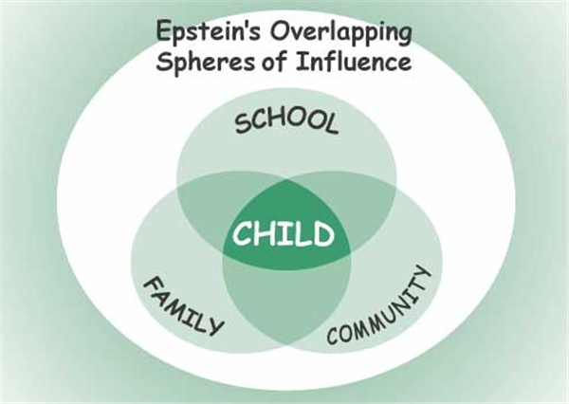

School Responsibilities

Willow Brook Elementary School staff will partner with parents to provide a world-class education to our students with:
- High quality curriculum and instruction in a supportive and effective learning environment provided by
  - Enabling participating students to meet the State’s academic achievement standards.
  - Implementing scientifically-based instructional programs and strategies to help your child achieve success.
  - Holding your child and ourselves to high expectations.
  - Determining your child’s educational needs and adjusting instruction to accommodate those needs.
  - Providing a safe and respectful environment for learning.
  - Ensuring that families have access to appropriate services and receive assistance as needed through referrals to the ORS Family Resource Center.
  - Host curriculum-based family night events to engage families in the learning process.
- Regular communication with parents/ families regarding student academic and behavioral progress.
  - Hosting at least one Open House/ Grade Level Orientation event at the beginning of each school year.
  - Holding parent-teacher conferences to discuss your child’s achievement. Specifically, these conferences will be held:
    - In the fall semester (October 20 & 21)
    - In the spring semester (February 10 & 11)
    - And, as needed based from school staff and/or parent concerns
  - Providing grade level-specific information about the academic content we are focusing on each grading period and ideas for how parents can support their student’s mastery of these concepts outside the classroom. This will be communicated through weekly newsletters and updates on the school website.
  - Providing parents with frequent reports and sharing information about your student’s academic and behavioral progress. Progress reports will be communicated quarterly through standards-based report cards, as needed by telephone and/or electronic communication, and by parent-teacher conferences at least one per semester.
  - Reserving time to talk with parents before school, after school, and during some teacher planning times.
- Provide parents opportunities to volunteer and participate in their student’s class and observe classroom activities, including:
  - Serving as a representative on school improvement and advisory committees.
    - This is as an opportunity for shared decision-making with regard to best practices for serving students and families at Willow Brook.
  - Chaperoning field trips.
  - Helping with special classroom projects and school events.
  - Listening to children read.
- Increase resources and opportunities for our students through relationships with community partners.

Family Responsibilities

As parents and family members who are interested in giving our student(s) the best possible opportunity to learn and to create new opportunities for themselves and their future, I/we will do all that I/we can to:
- Make sure my student arrives on time for school each day.
- Make sure that homework is complete.
- Read with my student daily.
  - K-2nd grade: 20 minutes of reading per day
  - 3rd/4th grade: 30 minutes of reading per day
- Volunteer in my child’s classroom and/or in the school, as I am able. Opportunities include:
  - Classroom volunteering
  - School project/ program volunteering
  - Serving on Parent Advisory Board for the school and/or school district
  - Participating in PTO events that support student activities
- Keep my contact information as current as possible to ensure timely and responsive two-way communication between home and school.
- Participate, as appropriate, in decisions relating to my student’s education as well as parent-teacher conferences. If I/we have any concerns about my child’s learning experiences, I/we will contact the classroom teacher and/or school administrator to schedule a specific time to discuss my child’s progress and obstacles he/she may be facing.
- Stay informed about my student’s education and communication with the school by promptly reading all notices from the school or the school district and respond appropriately.
- Support a safe, responsible, and respectful climate by reviewing Positive Behavior Expectations with my student and partner with Willow Brook staff to hold him/her accountable for meeting these expectations.

Student Responsibilities

As a student, I will share in the responsibility of my academic achievement in the following ways:
- Follow the Willow Brook Promise:
  - Be Honest.
  - Be Courteous.
  - Be respectful.
  - Be responsible.
  - Be a hard worker at all times.
- Complete my classroom and homework assignments.
- Follow responsible, respectful, and safe behavior expectations in all areas of the school, including the bus.
- Read with an adult, sibling, and/or pet outside of school every day.
  - K-2nd grade: 20 minutes of reading per day
  - 3rd/4th grade: 30 minutes of reading per day
- Be responsible by getting all information from school to my parents.

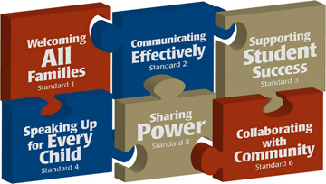
Please sign and return the attached letter and parent handbook order form by September 18, 2020.

