Anderson County Democratic Women’s Club

Scholarship Opportunity!

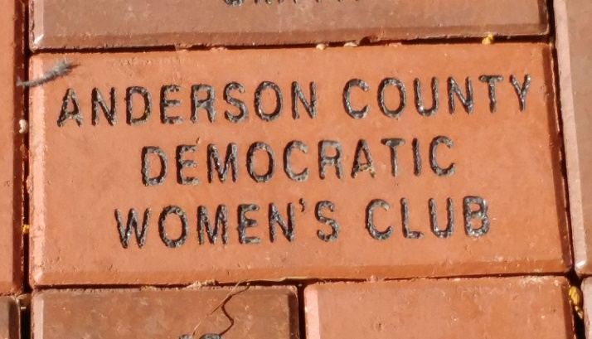

This scholarship is awarded yearly
to a female student
who plans to attend a local college
or other institution.

Fill out your school’s common scholarship application
and attach an essay explaining why
you would be a good candidate
for this scholarship.

For more information, contact Mary Zuhr at maryzuhr@gmail.com
or Ann Mostoller at amostoller@msw-law.com

