Willow Brook Elementary School

Title I School-Family Compact

The faculty of Willow Brook Elementary School believes that education is a cooperative venture between family, school, and community in support of flourishing child development. Parents are a child’s first and best teachers! We count on you, and you can count on us to love your child and challenge him/her to achieve their greatest potential. Parental involvement is often the key to a positive school experience, and we look forward to working with you in the coming year. This document outlines how parents, students, and staff of Willow Brook Elementary School will collaborate to share responsibility for creating a safe and welcoming campus and improving student academic achievement. This School-Family Compact is in effect during the 2017-2018 school year. Please read this compact, sign, and return to your student’s homeroom teacher.

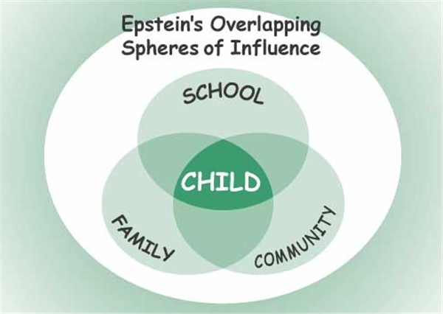

School Responsibilities

In order to offer a world-class education to our students and facilitate a true partnership with our families, the Willow Brook Elementary School staff will:
- Provide high quality curriculum and instruction in a supportive and effective learning environment by
  - Enabling the participating students to meet the State’s academic achievement standards.
  - Implementing scientifically based instructional programs and strategies to help your child achieve success.
  - Having high expectations for your child and for ourselves.
  - Determining your child’s educational needs and adjusting the instruction to accommodate those needs.
  - Providing a safe and respectful environment for learning.
  - Ensuring that families have access to appropriate services and receive the assistance as needed through referrals to the ORS Family Resource Center.
  - Host curriculum-based family night events to engage families in the learning process.
- Communicate regularly with parents/ families regarding student academic and behavioral progress.
  - Host at least one Open House/ Grade Level Orientation event at the beginning of each school year.
  - Hold parent-teacher conferences during which your individual student’s achievement will be discussed. Specifically, these conferences will be held:
    - In the fall semester (November 1 & 2)
    - In the spring semester (February 21 & 22)
    - As needed based on concerns from school staff and/or parent
  - Provide grade-level specific information regarding the academic content focus for each grading period and ideas for how parents can support their student’s mastery of these concepts outside the classroom. This will be communicated through weekly newsletters and updates on the school website.
  - Provide parents with frequent reports that share information about your student’s individual academic and behavioral progress. Progress reports will be communicated through standards-based report cards (quarterly), telephone calls and/or electronic communication (as needed), and parent-teacher conferences (at least one per semester).
  - Staff will be available for consultation with parents before school, after school, and during some teacher planning times.
- Provide parents opportunities to volunteer and participate in their student’s class and observe classroom activities as follows:
  - Serve as a representative on school improvement and advisory committees as an opportunity for shared decision-making with regard to best practices for serving students and families at Willow Brook.
  - Chaperone field trips
  - Help with special classroom projects and school events
  - Listen to children read
- Develop community partnerships to increase the resources and opportunities available to our students.

Family Responsibilities

As parents and family members who are interested in giving our student(s) the best possible opportunity to learn and to create new opportunities for themselves and their future, I/we will do all that I/we can to:
- Make sure my student arrives on time for school each day.
- Make sure that homework is complete.
- Read with my student daily.
  - K-2nd grade: 20 minutes per day
  - 3rd/4th grade: 30 minutes per day
- Volunteer in my child’s classroom and/or in the school, as I am able. Opportunities include:
  - Classroom volunteer
  - School project/ program volunteer
  - Serve on Parent Advisory Board or school and/or school district
  - Participate in PTO events that support student activities
- Keep my contact information as current as possible to ensure timely and responsive two-way communication between home and school.
- Participate, as appropriate, in decisions relating to my student’s education. I/we will participate in parent-teacher conferences. If I/we have any concerns about my child’s learning experiences, I/we will contact the classroom teacher and/or school administrator in order to schedule specific time to discuss my child’s progress and obstacles he/she may be facing.
- Stay informed about my student’s education and communication with the school by promptly reading all notices from the school or the school district and respond, as appropriate.
- Support a safe, responsible, and respectful climate by reviewing Positive Behavior Expectations with my student and partner with Willow Brook staff to hold him/her accountable for meeting these expectations.

Student Responsibilities

As a student, I will share in the responsibility of my academic achievement in the following ways:
- Follow the Willow Brook Promise:
  - Be Honest.
  - Be Courteous.
  - Be respectful.
  - Be responsible.
  - Be a hard worker at all times.
- Complete my classroom and homework assignments.
- Follow responsible, respectful, and safe behavior expectations in all areas of the school, including the bus.
- Read with an adult, sibling, and/or pet outside of school every day.
  - K-2nd grade: 20 minutes per day
  - 3rd/4th grade: 30 minutes per day
- Be responsible in getting all information received from school to my parents.

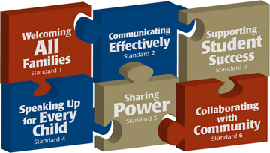
Please sign and return the attached letter and parent handbook order form by August 4, 2017.

