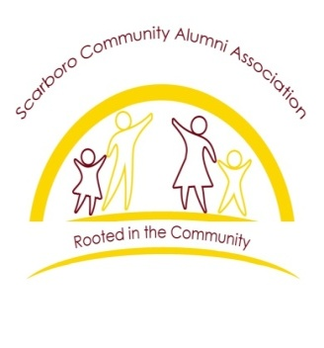
SCAA Call for 2024 Scholarship Recipients

The Scarboro Community Alumni Association was formed in the fall of 2011. Our objective is to revitalize our community, instill community pride, and serve as mentor to the youth in the neighborhood. The Alumni Association is made up of current and former neighborhood residents who have a desire to make an impact within our community while assisting children in our neighborhood to reach their full potential.

The Scarboro Community Alumni Association (SCAA) scholarship serves as a way of seeding into the youth of the Scarboro community. We offer scholarships to high school graduates who continue on with their education, whether 2 or 4 year college/university.

The application packet for the Scarboro Community Alumni Association will be made available at area high schools, community organizations and churches. We ask that you complete the form and submit the application and essay no later than May 10, 2024. Application postmarked later then this date will not be accepted. The application packet must be mailed to:

Scarboro Community Alumni Association (SCAA)
2024 Scholarship
P.O.Box 147
Suite 107-A
1143 Oak Ridge Turnpike
Oak Ridge, TN 37830
Prerequisites for Applying:
- Must have an association with the Scarboro Community.
- Must have attended Oak Ridge High School or surrounding area high school.
- Must be enrolled in a two or four year undergraduate program (show proof such as class schedule and letter of acceptance).
- Must have high school transcript.
- Must have two references, one a teacher and another community leader.
- Must submit a 400 word typed essay entitled ‘Why We Should Honor the Oak Ridge Scarboro 85.” View the WBIR Series “The Secret in Scarboro,Oak Ridge, Tennessee. https://www.youtube.com. Review reference material at Oak Ridge Public Library or interview Oak Ridge-Scarboro 85 students.

We look forward to receiving your application.

Scarboro Community Alumni Scholarship Committee
John Spratling (chair) and Cynthia Manley (member)

